剑桥

<https://www.graduate.study.cam.ac.uk/courses>

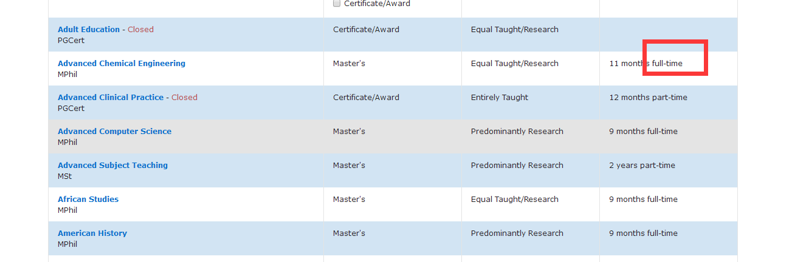只需要full time的专业名与对应的链接，part time的不需要

牛津

<https://www.ox.ac.uk/admissions/graduate/courses/courses-a-z-listing?wssl=1>

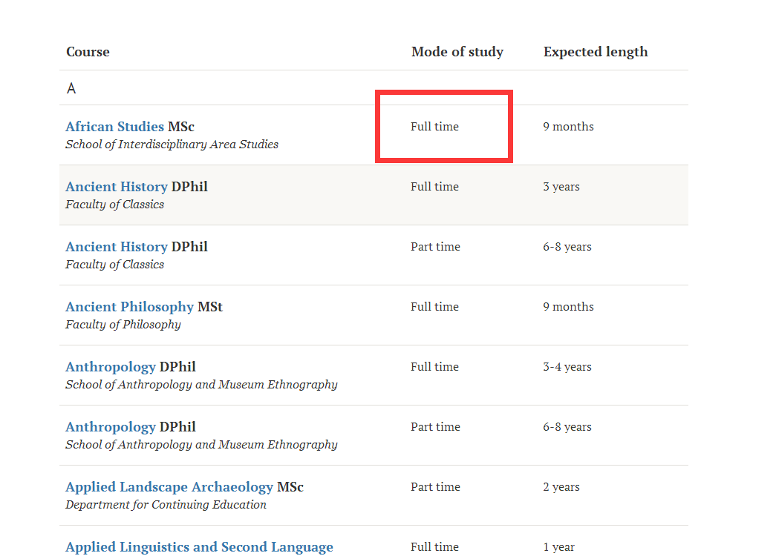

只需要full time的专业名与对应的链接，part time的不需要

帝国理工

http://www.imperial.ac.uk/study/pg/courses/

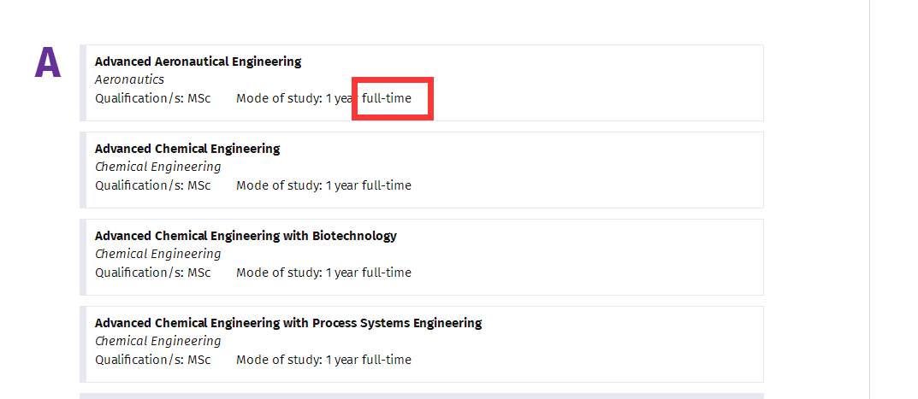

LSE

http://www.lse.ac.uk/study-at-lse/Graduate/Available-programmes

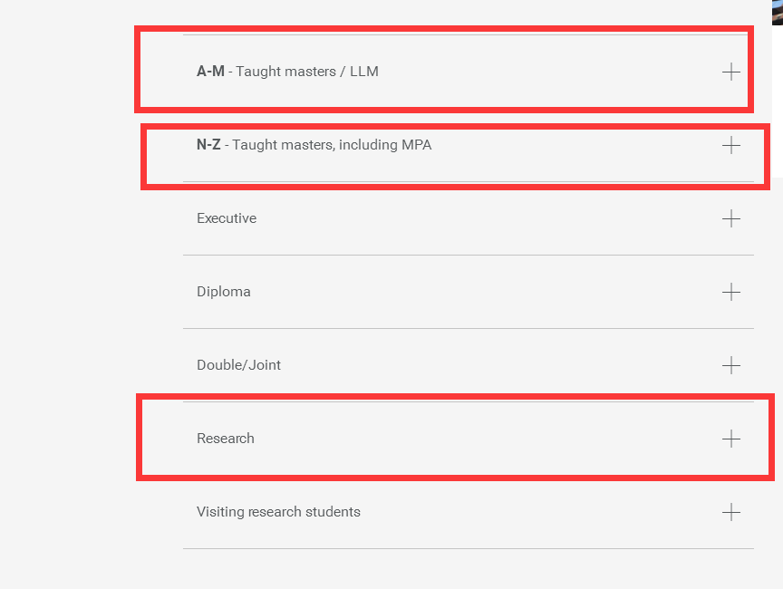

需要打开这三个，然后提取里面的专业和链接

UCL

<http://www.ucl.ac.uk/prospective-students/graduate/taught/degrees>

<http://www.ucl.ac.uk/prospective-students/graduate/research/degrees>

以上链接里的全部专业与链接

Edinburgh

<https://www.ed.ac.uk/studying/postgraduate/degrees/index.php?r=site%2Fsearch&pgSearch=&yt0=&moa=a>

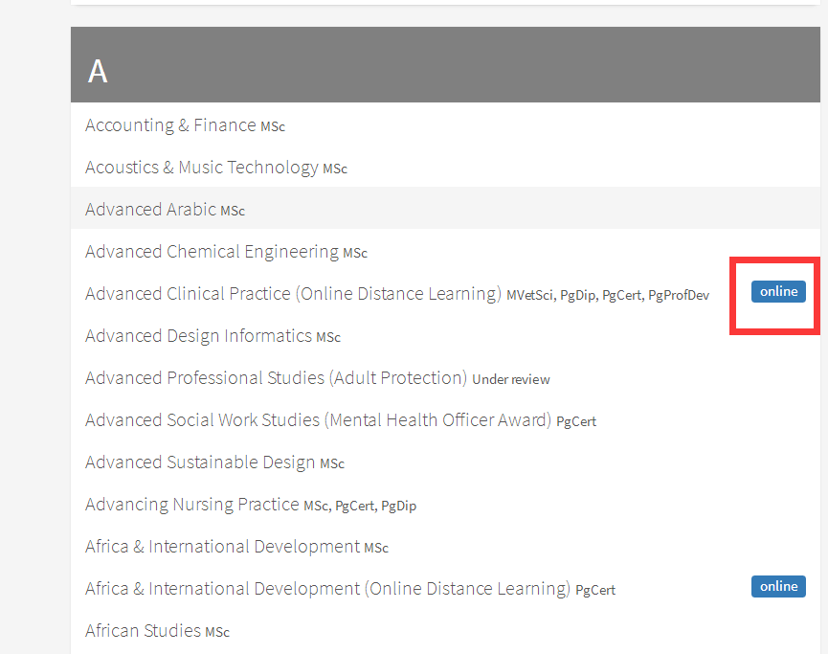有这个标志的专业不要，其它都要

KCL

<https://www.kcl.ac.uk/search/search.aspx#/courses?level=5089%2C5088&delivery=5084&studyMode=5078>

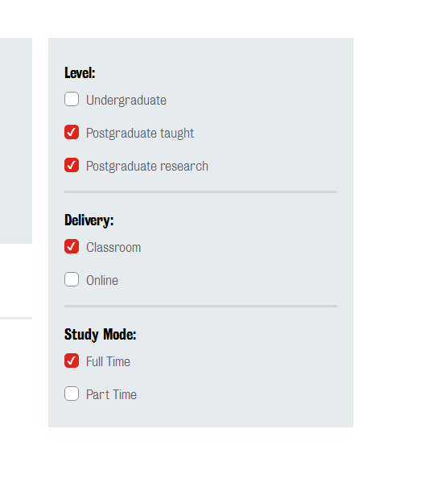这四个地方打钩

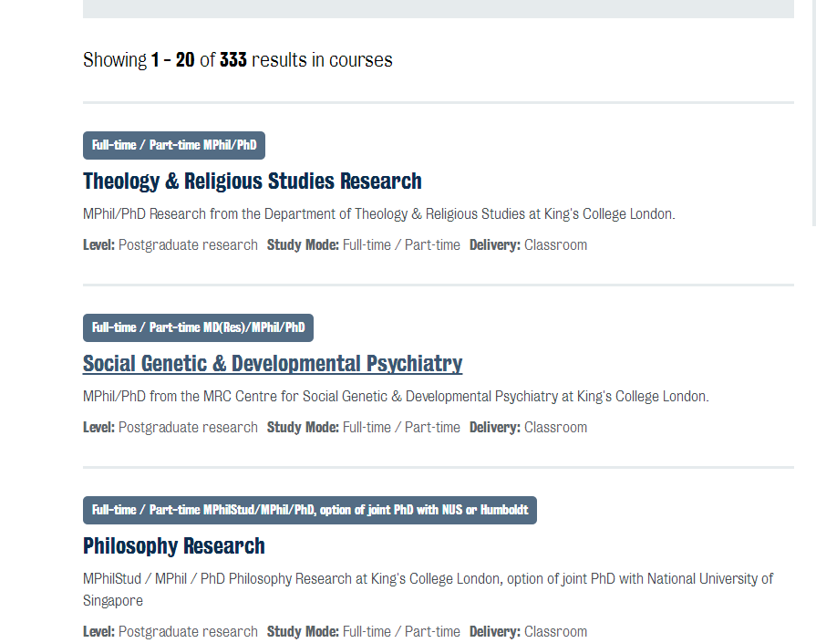需要所有333个专业和链接

Manchester

<http://www.manchester.ac.uk/study/masters/courses/list/>

<http://www.manchester.ac.uk/study/postgraduate-research/programmes/list/>

这两个链接的所有专业和链接

Bristol

<http://www.bris.ac.uk/study/postgraduate/search/>

链接里的所有专业和链接

Glasgow

<https://www.gla.ac.uk/postgraduate/taught/>

<https://www.gla.ac.uk/research/opportunities/>

这两个链接的所有专业和链接

Warwick

<https://warwick.ac.uk/study/postgraduate/courses-2018/>

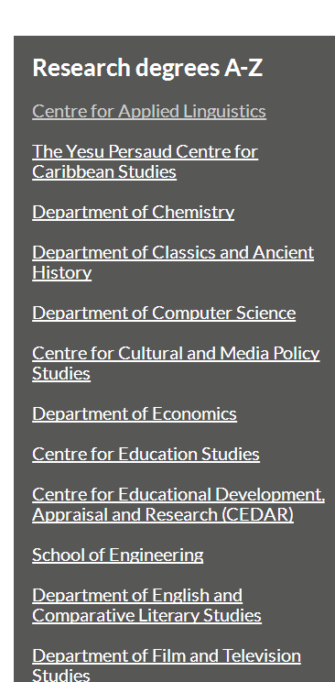这一部分的内容也要

链接里的所有专业和链接

Durham

<https://www.dur.ac.uk/courses/all/#indexA>

选择这些选项

A-V所有专业与链接

<https://www.dur.ac.uk/study/pg/studyoptions/research/>

上面所有专业与链接

Sheffield

<https://www.sheffield.ac.uk/postgraduate/taught/courses/all>

上面所有专业与链接

<https://www.sheffield.ac.uk/postgraduate/research/areas/index>

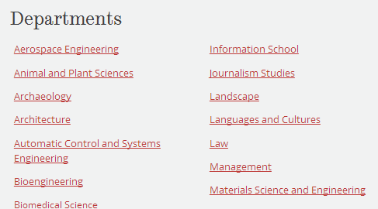

每一个department里面的postgraduate research和PHD专业与链接

Queenmary

http://search.qmul.ac.uk/s/search.html?collection=queenmary-coursefinder-pg&query=&f.Mode%7CM=full+time&sort=title

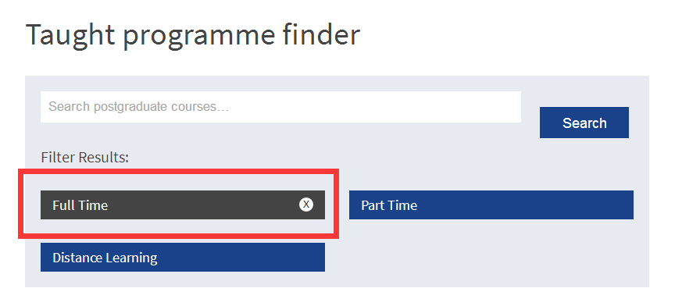

选fulltime后的所有专业和链接

<https://www.qmul.ac.uk/postgraduate/research/>



选all之后的所有专业和链接

Exeter

<https://www.exeter.ac.uk/postgraduate/all-courses/>

所有专业和链接

<https://www.exeter.ac.uk/pg-research/degrees/>



所有专业和链接

Southampton

<https://www.southampton.ac.uk/courses/taught-postgraduate.page>

所有专业和链接

<https://www.southampton.ac.uk/courses/research-postgraduate.page>

所有专业和链接

York

<https://www.york.ac.uk/study/postgraduate/courses/all?mode=taught>

所有专业和链接

<https://www.york.ac.uk/study/postgraduate/courses/all?mode=research>

所有专业和链接

Leeds

<https://courses.leeds.ac.uk/course-search?query=&type=PGT>

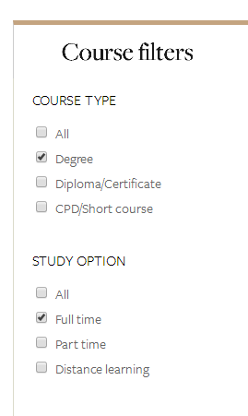选择后所有专业和链接

<https://courses.leeds.ac.uk/course-search?query=&type=PGR&term=201819>



选择后所有专业和链接

Birmingham

<https://www.birmingham.ac.uk/postgraduate/courses/search.aspx#CourseComplete_AtoZTab>

A-Z所有

<https://www.birmingham.ac.uk/postgraduate/courses/research/search.aspx?CurrentTab=AtoZ&CourseComplete_AtoZ_AtoZLetter=A>

A-Z所有

St Andrews

<https://www.st-andrews.ac.uk/subjects/>

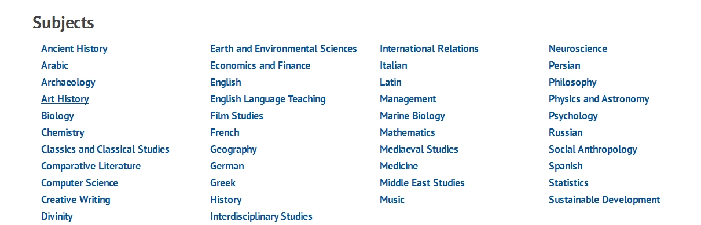

每一个subject摁进去

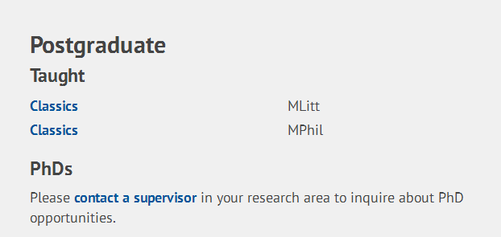

然后需要postgraduate的部分

Nottingham

<https://www.nottingham.ac.uk/pgstudy/courses/courses.aspx>

以上链接的全部专业与链接

Sussex

<http://www.sussex.ac.uk/study/masters/>

<http://www.sussex.ac.uk/study/phd>

以上链接的全部专业与链接

Lancaster

<http://www.lancaster.ac.uk/study/postgraduate/postgraduate-courses/>

以上链接的全部专业与链接

Leicester

<https://le.ac.uk/courses>

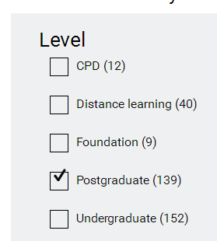选择这个之后的所有专业与链接

Cardiff

<https://www.cardiff.ac.uk/study/postgraduate/taught/courses/a-to-z>

<https://www.cardiff.ac.uk/study/postgraduate/research/programmes/a-to-z>

以上链接的全部专业与链接

Newcastle

<http://www.ncl.ac.uk/postgraduate/courses/#a-z>

以上链接的全部专业与链接

Liverpool

<https://www.liverpool.ac.uk/study/postgraduate-taught/courses/>

<https://www.liverpool.ac.uk/study/postgraduate-research/opportunities/>

以上链接的全部专业与链接

Aberdeen

<https://www.abdn.ac.uk/study/postgraduate-taught/degree-programmes/>

<https://www.abdn.ac.uk/study/postgraduate-research/research-areas/>

以上链接的全部专业与链接

Dundee

<https://search.dundee.ac.uk/s/search.html?collection=courses&query=&sort=title&f.Level|L=pgt&f.Mode|M=ft>



Level选postgraduate taught，Mode选fulltime

然后所有的专业与链接

UEA

[https://www2.uea.ac.uk/study/course-finder?_&courseSearchString=*&level=pg&_&_ga=2.47330023.1379399807.1521797458-1345784231.1521797458](https://www2.uea.ac.uk/study/course-finder?_&courseSearchString=*&level=pg&_&_ga=2.47330023.1379399807.1521797458-1345784231.1521797458)

所有的专业与链接

RHUL

<https://www.royalholloway.ac.uk/courses/postgraduate/home.aspx>

所有的专业与链接

Queen belfast

<http://www.qub.ac.uk/courses/postgraduate-taught/?keyword=>

所有的专业与链接

Reading

<https://www.reading.ac.uk/Ready-to-Study.aspx>

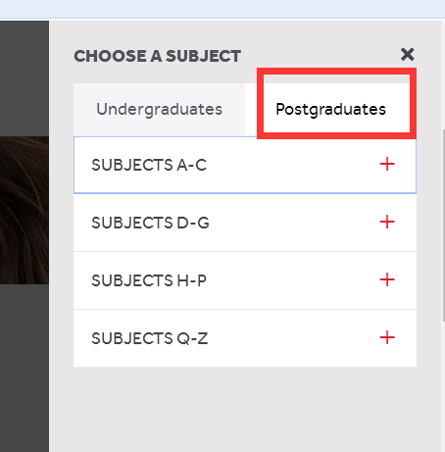展开所有，专业与链接

Bath

<http://www.bath.ac.uk/courses/postgraduate-2018/taught-postgraduate-courses/>

所有专业与链接

<http://www.bath.ac.uk/guides/how-to-apply-for-doctoral-study/#select-a-research-programme>



每一个方向摁进去，然后选所有专业与链接

Essex

<https://www.essex.ac.uk/masters/courses>

所有专业与链接

<https://www1.essex.ac.uk/pgr/>

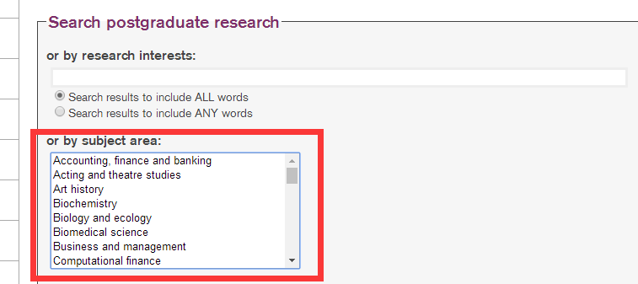

每一个subject area里的专业与链接

Surrey

<https://www.surrey.ac.uk/postgraduate>

<https://www.surrey.ac.uk/postgraduate/research>

链接里所有专业与链接

Swansea

<http://www.swansea.ac.uk/postgraduate/research/>

http://www.swansea.ac.uk/postgraduate/taught/



选complete A-Z的所有专业与链接

Bangor University

Master：<https://www.bangor.ac.uk/courses/postgraduate/> 选所有方向，所有链接都需要

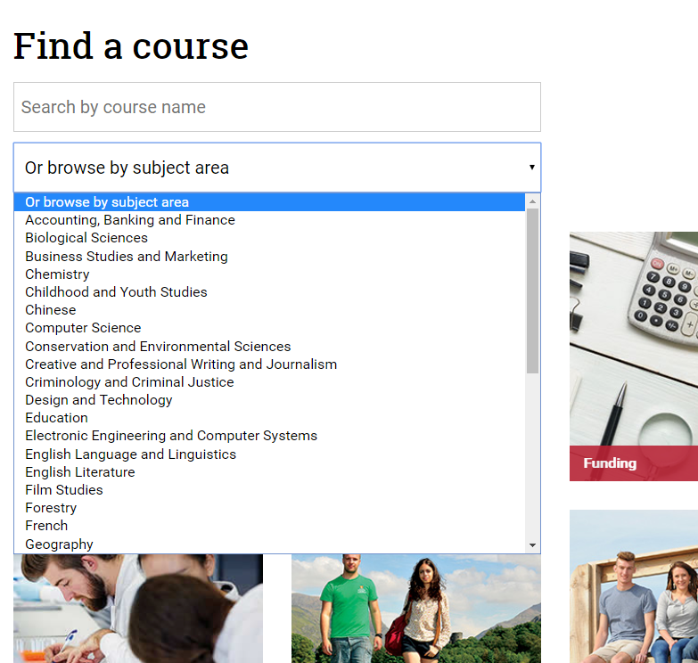

Loughborough University

Master：<http://www.lboro.ac.uk/study/postgraduate/masters-degrees/a-z/>

Research：http://www.lboro.ac.uk/study/postgraduate/research-degrees/unfunded/分别选三个方向，所有专业和链接都需要

Goldsmiths, University of London

<https://www.gold.ac.uk/pg/a-z/>

University of Stirling

master：<https://www.stir.ac.uk/postgraduate/programme-information/>

Research： <https://www.stir.ac.uk/postgraduate/research-degrees/>

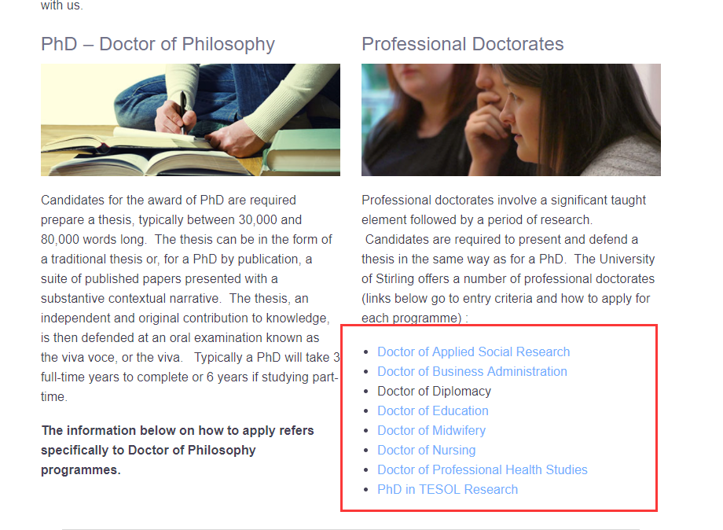以第一个为例，点进去后，下框所有链接都需要

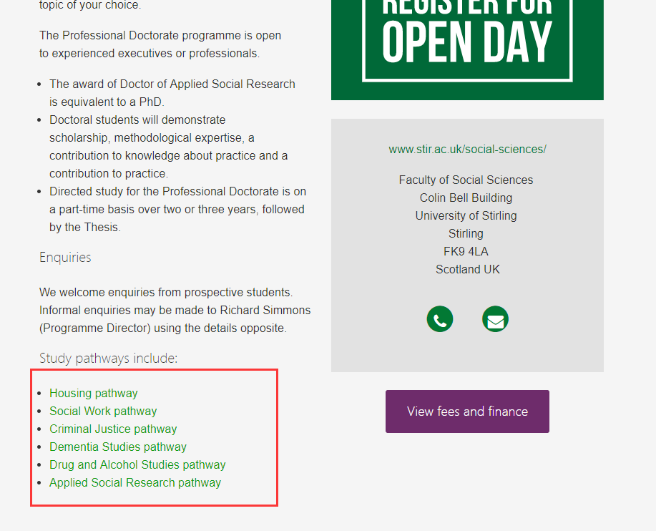

University of Kent

Master：<https://www.kent.ac.uk/courses/postgraduate/search/> mode选full time

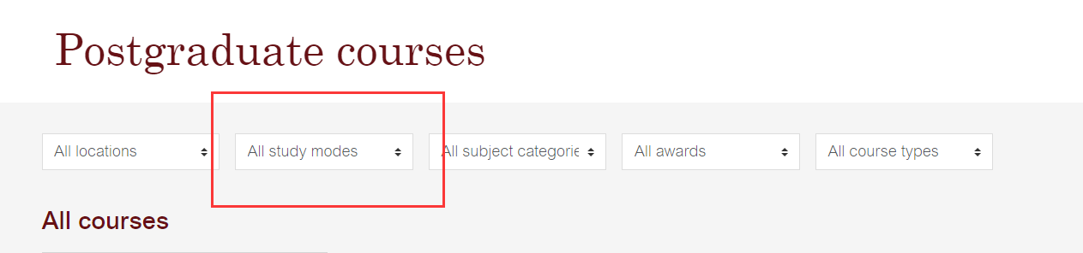

Research： <https://www.kent.ac.uk/courses/postgraduate/research-phds/> 所有都需要

